Crack Detection Project

Basit Ali (FA19-Bse-031)

Etsham Zaid (FA19-Bse-042)

import cv2  
import math  
import numpy as np  
import scipy.ndimage  
  
def orientated_non_max_suppression(mag, ang):  
 ang_quant = np.round(ang / (np.pi/4)) % 4  
 winE = np.array([[0, 0, 0],[1, 1, 1], [0, 0, 0]])  
 winSE = np.array([[1, 0, 0], [0, 1, 0], [0, 0, 1]])  
 winS = np.array([[0, 1, 0], [0, 1, 0], [0, 1, 0]])  
 winSW = np.array([[0, 0, 1], [0, 1, 0], [1, 0, 0]])  
  
 magE = non_max_suppression(mag, winE)  
 magSE = non_max_suppression(mag, winSE)  
 magS = non_max_suppression(mag, winS)  
 magSW = non_max_suppression(mag, winSW)  
  
 mag[ang_quant == 0] = magE[ang_quant == 0]  
 mag[ang_quant == 1] = magSE[ang_quant == 1]  
 mag[ang_quant == 2] = magS[ang_quant == 2]  
 mag[ang_quant == 3] = magSW[ang_quant == 3]  
 return mag  
  
def non_max_suppression(data, win):  
 data_max = scipy.ndimage.filters.maximum_filter(data, footprint=win, mode='constant')  
 data_max[data != data_max] = 0  
 return data_max  
  
# start calulcation  
gray_image = cv2.imread(r'C:\Users\Asif Bashir\Downloads\road images\crack.jpg', 0)  
  
with_nmsup = True #apply non-maximal suppression  
fudgefactor = 1.3 #with this threshold you can play a little bit  
sigma = 21 #for Gaussian Kernel  
kernel = 2*math.ceil(2*sigma)+1 #Kernel size  
  
gray_image = gray_image/255.0  
blur = cv2.GaussianBlur(gray_image, (kernel, kernel), sigma)  
gray_image = cv2.subtract(gray_image, blur)  
  
# compute sobel response corner dector  
sobelx = cv2.Sobel(gray_image, cv2.CV_64F, 1, 0, ksize=3)  
sobely = cv2.Sobel(gray_image, cv2.CV_64F, 0, 1, ksize=3)  
mag = np.hypot(sobelx, sobely)  
ang = np.arctan2(sobely, sobelx)  
  
# threshold  
threshold = 4 * fudgefactor * np.mean(mag)  
mag[mag < threshold] = 0  
  
#either get edges directly  
if with_nmsup is False:  
 mag = cv2.normalize(mag, 0, 255, cv2.NORM_MINMAX)  
 kernel = np.ones((5,5),np.uint8)  
 result = cv2.morphologyEx(mag, cv2.MORPH_CLOSE, kernel)  
 cv2.imshow('im', result)  
 cv2.waitKey()  
  
#or apply a non-maximal suppression  
else:  
  
 # non-maximal suppression  
 mag = orientated_non_max_suppression(mag, ang)  
 # create mask  
 mag[mag > 0] = 255  
 mag = mag.astype(np.uint8)  
  
 kernel = np.ones((5,5),np.uint8)  
 result = cv2.morphologyEx(mag, cv2.MORPH_CLOSE, kernel)  
  
 cv2.imshow('im', result)  
 cv2.waitKey()

ORGINAL IMAGE

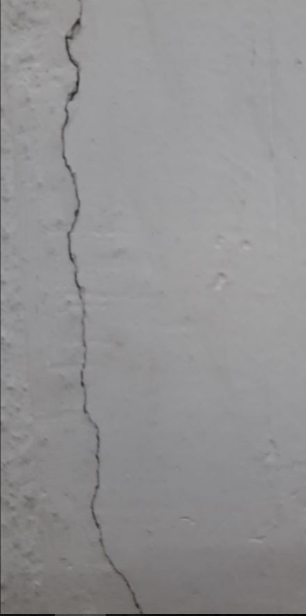

RESULT

